Why is this different? When it comes to the display of tags, the browser recognizes three groups of elements:
- inline
- block-level
- inline block-level
Inline elements do not cause transitions to a new line, but will be displayed one next to the other horizontally. Block elements are set like blocks that stack on top of each other and will never display next to one another horizontally, unless we use magic tricks in CSS (which we'll learn in the next chapter). Inline blocks will act as inline elements (elements are displayed next to each other), but differ in that they can be for instance resized. For example, the <textarea> field can be displayed as a large rectangle, but it can take up space beyond a single line of text.
Let me share with you some examples of items that can be classified according to one of the three groups.
- inline – <span>, <em>, <strong>
- block-level – <div>, <p>, <article>
- inline block-level – <input>, <textarea>
By default, inline elements have CSS display property set to inline. For block-level elements, its value is "block", and for inline block elements it's "inline-block". So you can explain that <span> tag doesn't cause breaking the text to the new line, because it's an inline element which means in CSS it has a property "display" set to "inline". So, considering the below code:
<span>one</span> <span>two</span> <span>three</span>
The browser will display above code in one line:
one two three
However, it's possible to change this behavior by adding one line of CSS:
span {
display: block;
}
Now, our <span> tags display differently, each one in a new line, since we have set their display property to block:
one
two
three
For this example, we use <div>. You may wonder what this tag describes within the document. The short answer is nothing. We use the <div> tag in cases where all other tags do not find a use for what we've put in the document. It is common, therefore, that the <div> tag (in conjunction with other classes) is used to achieve different visual effects, as a result of it having no function for describing content. For example, if you want to make three vertical columns on our website, we might need an item that can separate some elements of inline or inline block elements.
In general, it's a good idea to not overuse the <div> tag if possible.
With our new found knowledge of blocks, let's make up our form code so that the form fields and their descriptions are displayed nicely one on top of the other:
<form>
<div>
<label for="nickname">Your nickname:</label>
</div>
<div>
<input type="text" id="nickname" name="nickname">
</div>
<div>
<label for="user-email">Your e-mail:</label>
</div>
<div>
<input type="email" id="user-email" name="user-email">
</div>
<div>
<label for="content">Content:</label>
</div>
<div>
<textarea rows="10" cols="50" id="content" name="content" ></textarea>
</div>
<div>
<input type="submit" value="Add">
</div>
</form>
It looks a bit more complicated, but the only thing we've done here is add <div> tags to surround each of the elements on the form.
Once again, let's look at a code comparison of our new code (left) against the old one (right):
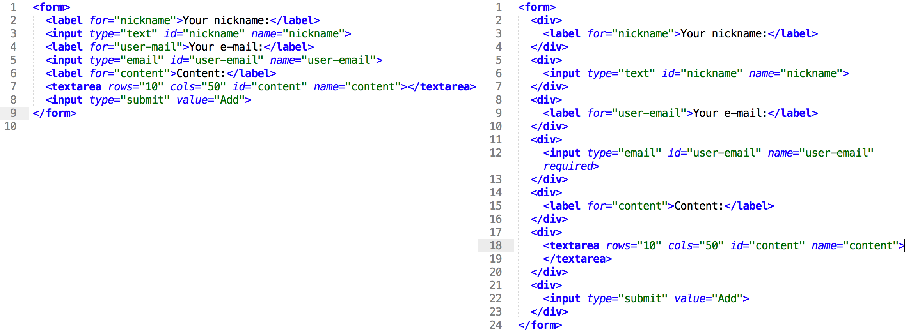
And now see how the new code displays in your browser!

